**The Spirit Of Indian Women**

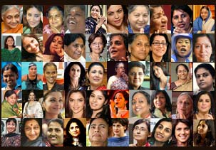

Within every woman is a storehouse of inexhaustible strength. In a country like ours, where women were believed to be the weaker sex for centuries, there were women who made their mark and became a great source of inspiration for women all over India. Today, we see women in each and every field, competing neck to neck with men, and even beating them at their own jobs. Here are a few landmarks in the history of women in India:



Within every woman is infinite enthusiasm.

1905, Suzanne R D Tata became the first Indian woman to drive a car.

Within every woman is an unquenchable thirst for knowledge.

1916, The first Women’s University (SNDT) was founded.

Within every woman is immeasurable potential.

1927, The All India Women’s conference was founded.

Within every woman is an indomitable spirit.

1951, Prem Mathur became the first Indian woman commercial pilot of the Deccan Airways.

Within every woman is infinite wisdom.

1959, Anna Chandy became the first Indian woman judge of the high court.

Within every woman is inestimable power.

1966,Indira Gandhi became the first Indian woman Prime Minister of India.

Within every woman is unstoppable resolve.

1970, Kamaljit Sandhu became the first Indian woman to win a gold at the Asian games.

Within every woman is an Iron will.

Kiran Bedi became the first female recruit to join the Indian Police Service.

Dhwani Sadaphal

EEE 3rd year